II B. Tech I Semester Regular Examinations - December, 2023
Probability Theory & Stochastic Processes
(ECE)
Time: 150 Min Max. Marks:80M

SECTION – A
Answer all Four questions 4×10M=40M

- A biologist assumes that there is a linear relationship between the amount of fertilizer supplied to tomato plants and the subsequent yield of tomatoes obtained.
Eight tomato plants, of the 'same variety, were elected at random and treated, weekly, with a solution in which x gram' of fertilizer was dissolved in a fixed quantity of water. The yield, kilograms, of tomatoes was recorded.

Plant | A | B | C | D | E | F | G | H
x | 1.0 | 1.5 | 2.0 | 2.5 | 3.0 | 3.5 | 4.0 | 4.5
y | 3.9 | 4.4 | 5.8 | 6.6 | 7.0 | 7.1 | 7.3 | 7.7

- Plot a scatter diagram of yield, y against amount of fertilizer, x. (2M)
- Determine the correlation coefficient. (4M)
- Calculate the equation of the regression line of y on x. (4M)

- In a certain assembly plant, three machines, B1, B2, and B3, make 30%, 45%, and 25%, respectively, of the products. It is known from past experience that 2%, 3%, and 2% of the products made by each machine, respectively, are defective. Now, suppose that a finished product is randomly selected.
- What is the probability that it is defective? (4M)
- If a product was chosen randomly and found to be defective, what is the probability that it was made by machine B3? (3M)
- If a product was chosen randomly and found to be defective, what is the probability that it was made by machine B2? (3M)

- Let X be a random variable with cumulative distribution function
$$F\left(x\right)= \left\{\begin{aligned} 0 x<0 \\ \frac{x}{4}+\frac{3x^{2}}{4} \\ 1 x≥1\end{aligned} \right.0 <x<1$$
- Find the mean and variance of X. (2M)
- Find $P(-1 < X < 2/3).$ (3M)
- If the density function of random variable is f(y)= u(t)-u(t-1), then determine the density of RV Z=X+Y (5M)

- The autocorrelation function of a random process X(t) is
$$R_{xx}(τ)=3+2 exp(-4τ²)$$
- Define power spectral density. (2M)
- Find the power spectrum of $X(t)$ average power contained. (4M)
- If $R_{xx}(τ)$ is applied to a system with $h(t)= 2tu(t),$ determine PSD of $Y(t)$ (4M)

SECTION - B
Answer all Two questions 2×20M=40M
- A privately owned business operates both a drive-in facility and a walk-in facility. On a randomly selected day, let X and Y, respectively, be the proportions of the time that the drive-in and the walk-in facilities are in use, and suppose that the joint density function of these random variables is
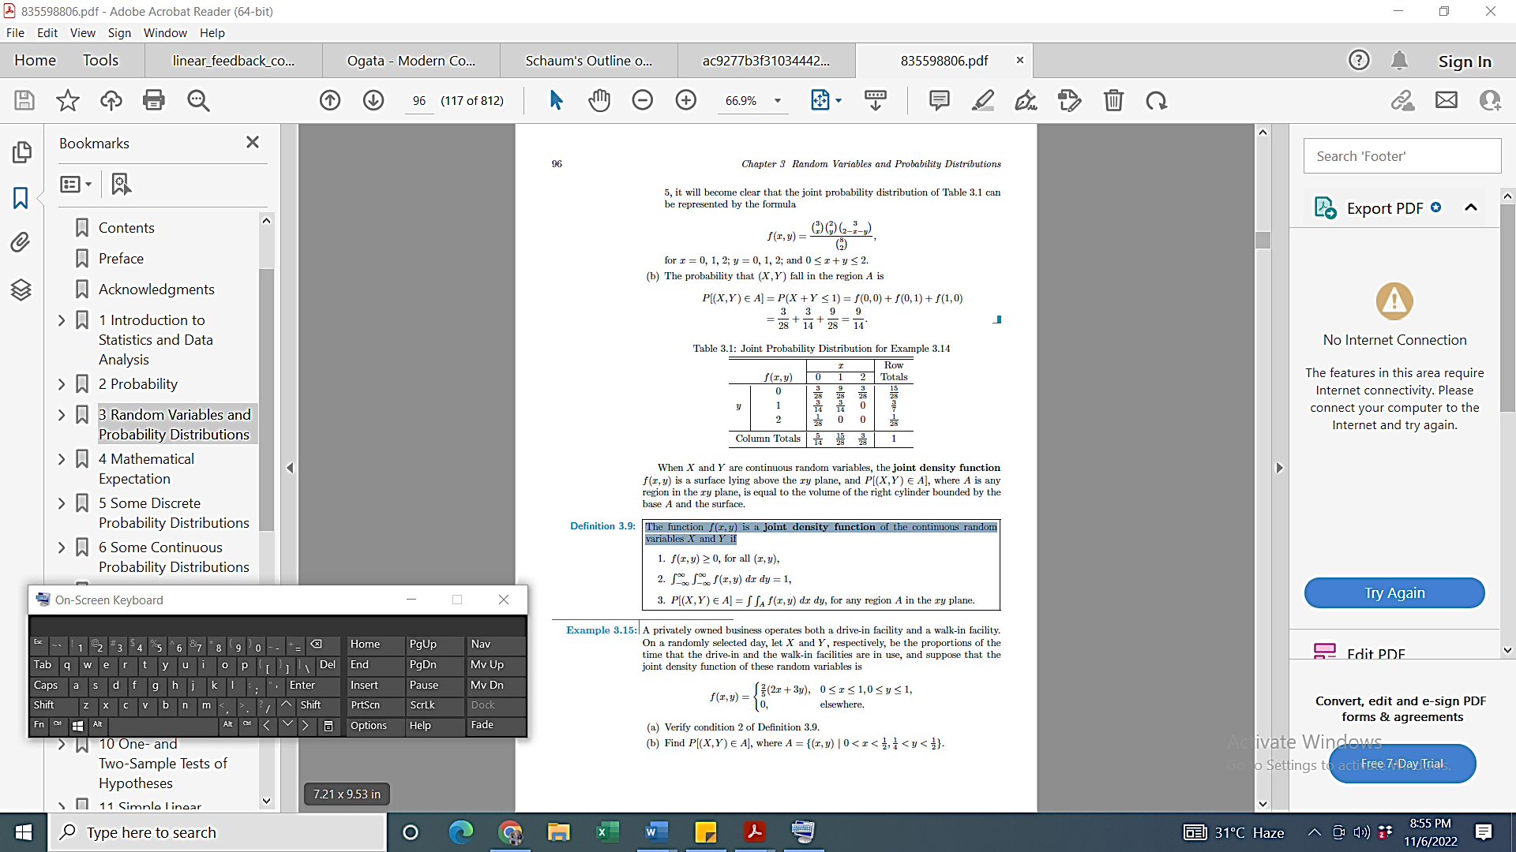
- Find $P[(X, Y ) ∈ A],$ where $A=\left\{\left(x,y\right)| 0<x<\frac{1}{2} and\frac{1}{4}<y<\frac{1}{2}\right\}$ (4M)
- Find marginal distributions of X alone and Y alone for the joint density function of $f(x,y)$. (6M)
- Determine correlation and covariance between random variable X and Y. (10M)

- Consider a random process $X(t)$ defined by
$$X\left(t\right)= A cos (ω_{0}t+θ) + B sin (ω_{0}t+θ) ,- π<θ <π$$
Where $θ$is uniformly distributed random variable in interval $(-π,π)$. Also, A and B are independent random variables with zero mean and unity variance.
- Calculate the mean and autocorrelation of random process $X(t)$. (6M)
- Is the process wide sense stationary? (4M)
- Find Power spectral density $S_{XX}(ω)$. (10M)

